Software Development and Testing Technician – Exam Project
Development Documentation 2025/26

Prepared by: Alex Tukarcs, Anaam Ali Al-Khayat, Szabolcs Nagy

Table of Contents:
• Database Installation
• Prgoram Installation
Introduction
Description

Introduction
We have developed a residential community management platform as our final exam project. We believe this application can be highly beneficial for managing the finances and shared responsibilities of multi-occupant households.
Users can easily track their upcoming expenses and assigned tasks, while a built-in chat allows them to discuss communal matters seamlessly. Our goal for the future is to expand the website with additional features and provide an even more convenient user experience."

Our homepage: 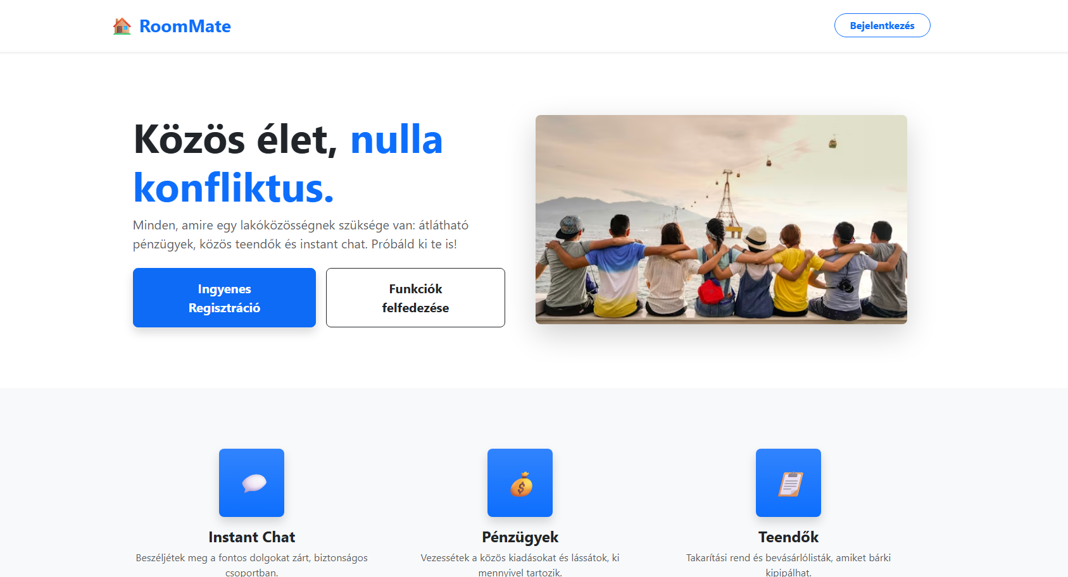
Our homepage displays the main features of the site, along with the registration and login menu options.
Login menu: 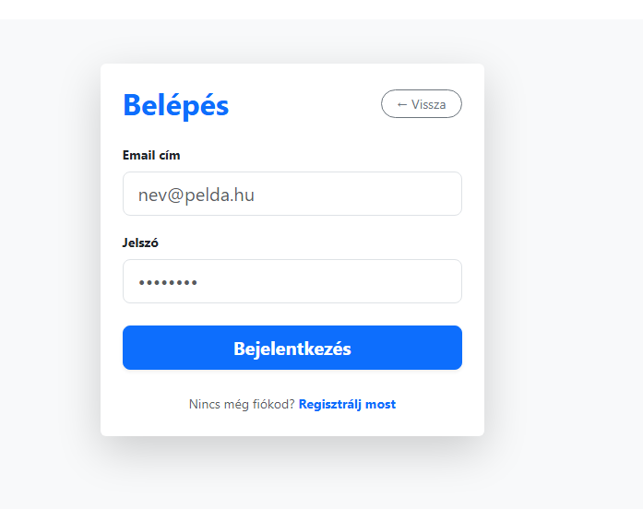

On the login menu you can log in with the combiantion of your email and password that you entered during the registartion process.

Registartion menu: 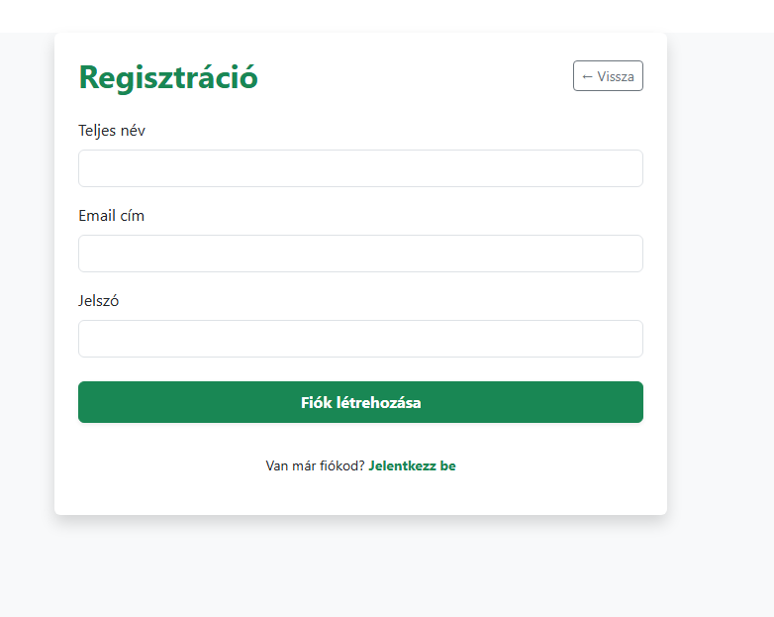
If you do not have an account already, you can register for a new one using your Full legal name, email address and password.

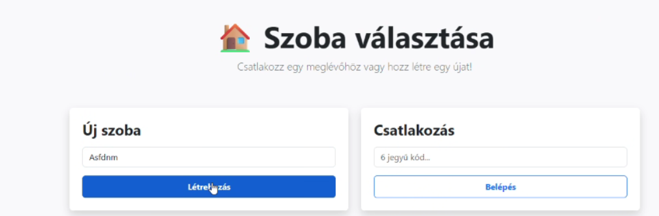
Room Selection:
After successfully logging in, you can choose to join an existing room, using the 6 character code, or create a new room.
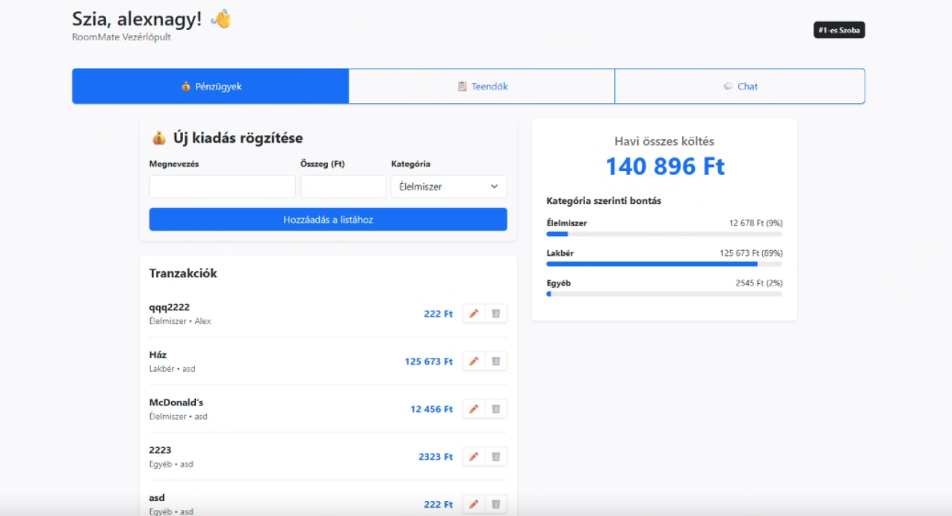
Main page:
On this main page, we can view, modify, and delete upcoming expenses.
First and foremost, we can record the name and amount of an expense, which must be assigned a type from a drop-down menu. Options include categories such as Utilities, Groceries, Rent, and Entertainment.
Once submitted, the Total Spending menu updates automatically, allowing us to see the overall expenditure as well as a breakdown by category."
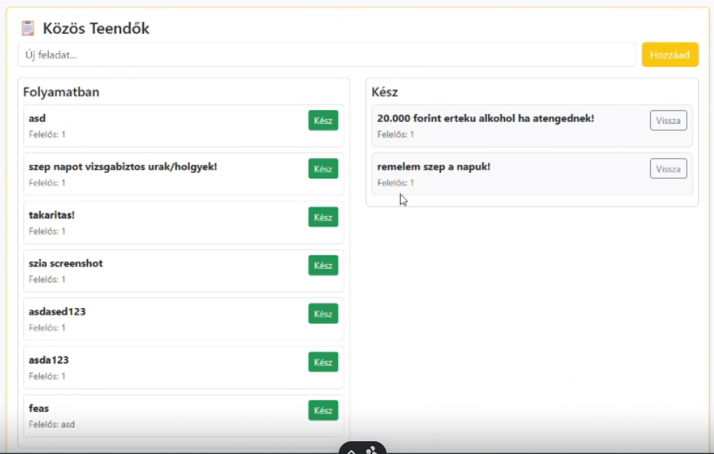
To-do Menu
This menu allows users to manage upcoming tasks, such as shopping or cleaning. A feature currently under development (WIP) allows users to assign specific individuals responsible for completing these activities.
Additionally, completed tasks can be separated from active ones, making it easy to track which items are still pending and which have already been finished."

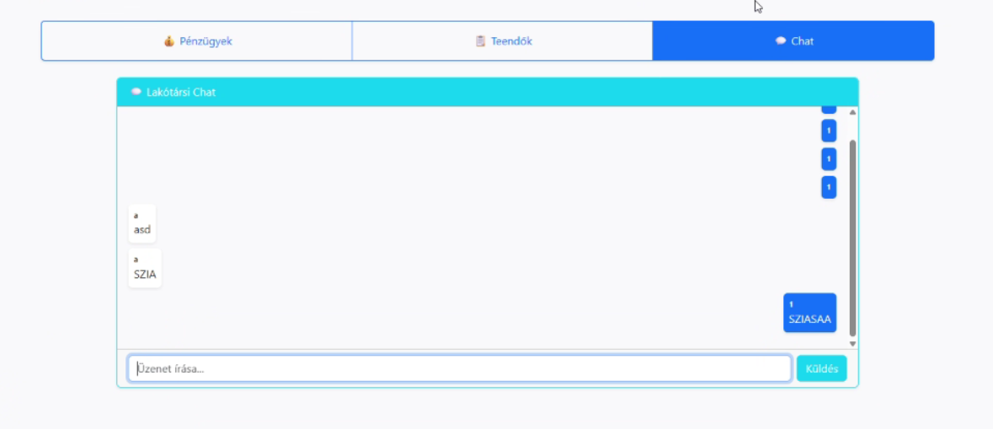

Roommate Chat menu
This menu provides users with a chat function, enabling conversation between members of the same group or residential community.
A planned future implementation for this menu includes the creation of separate threads. This will allow for better organization of conversations, preventing multiple different topics from running simultaneously within a single chat window.

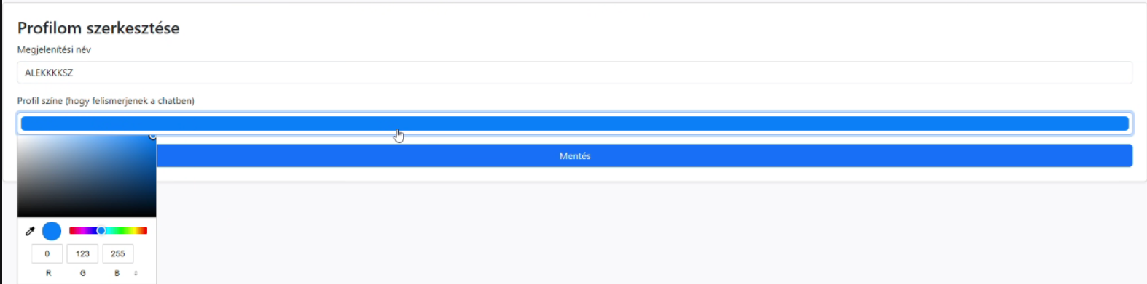
Profile Customization:
On the page, the users have the option to choose their display name, and user color, which helps differentiate between one another in chat, and the other menus on the website.

Future enhancements:
- Custom sub-categories within the finance module.
- A map feature showing user locations within a specific area (with an accuracy radius of approximately 2–3 km).
- Multi-group support, allowing users to join and manage multiple households simultaneously.
- Automated distribution of recurring expenses, which assigns payment amounts to each member based on predefined percentages.
- Implementation of a "Community Leader" role and related administrative functions.
- Inter-group event planning interface, enabling multiple communities to organize shared events.

Installation process
- The programs necessary for installing the project can be found in the developer documentation.
  - In the „frontend” folder of the project, we open a new command prompt, where we first execute the „npm install” command.
  - After the installation, we can launch the project from the same command prompt with the „npm start” command

Database installation

- Importing of the database can be done through the XAMPP control panel, where we import into an already existing , albeit empty database called roommate_db .
- We import the roommate_db.sql file into said databe.
- Apart from this step, we have no other task with the database.
- 